a private individual in Denmark or outside Denmark when no double taxation agreement has been concluded with the country.

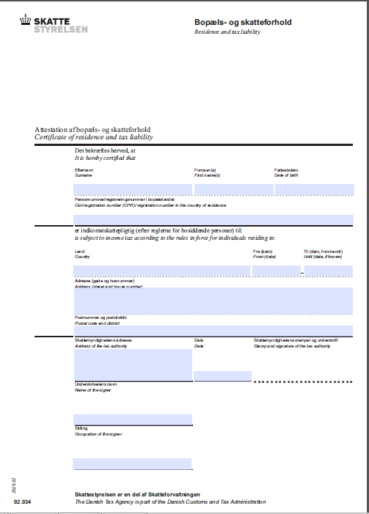

Residence and tax liability if a double taxation agreement exists, This form should be used to confirm the place of residence for tax purposes of a private individual in Denmark or outside Denmark when a double taxation agreement has been concluded with the country.

